POLICY PLAN

Mission
To drive sustainability in the superyacht industry through collaboration and innovation and leading the way to neutralise its ecological footprint and preserve the world’s precious oceans.

Goal
The ultimate goal of Water Revolution Foundation is to increase the awareness, urgency and actions by the entire maritime industry to reduce its environmental footprint, and repair and protect the world’s oceans.

Strategy
Through collaboration, knowledge sharing, education and developing practical but scientific tools, Water Revolution Foundation works from inside the superyacht industry to drive sustainability. The superyacht industry can utilize its unique position to lead the way for the wider maritime industry in driving sustainability and to repair and protect the oceans.

Our activities
Our activities are divided between three pillars:

TECHNOLOGY
Promoting new technology and empowering innovation to achieve a lighter footprint for the superyachting industry.

CONSERVATION
Taking responsibility to protect the beautiful oceans and improving the planet’s wellbeing.

POLICY
Pro-actively create industry’s own agenda, beyond legislative developments, initiating progressive steps and actively being part of international and cross-industry worktables.

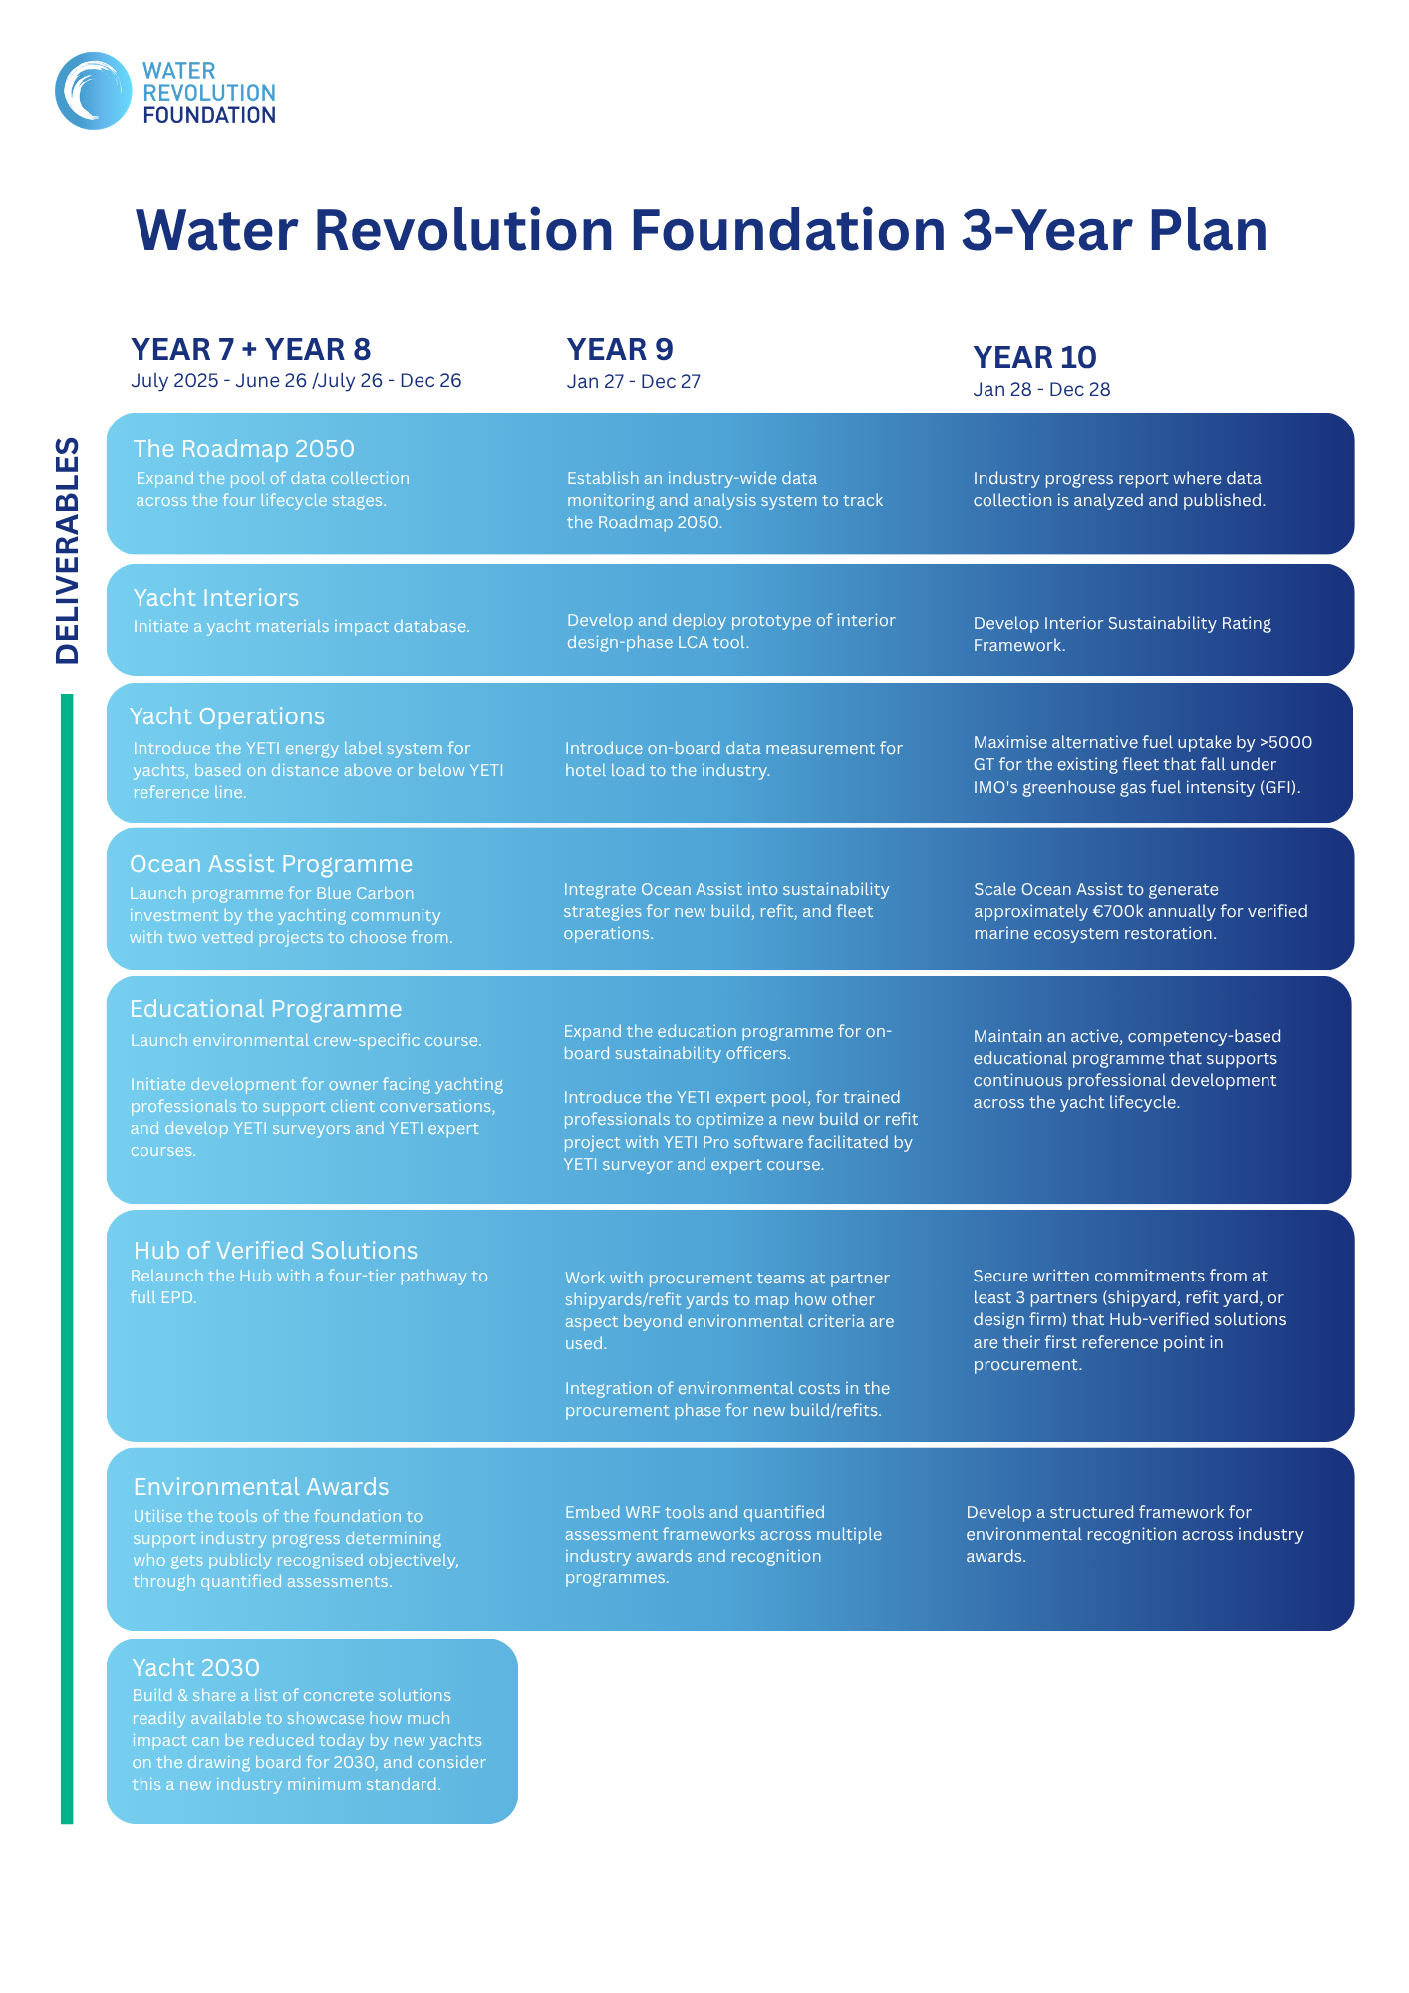

FUNDING
Water Revolution Foundation receives funding from the international superyacht industry. In line with our philosophy that the superyacht industry is in a unique and strategic position to lead the way for the wider maritime sector, industry companies and individuals are invited become partner of the foundation by contributing financial as well intellectual and human resources. Additional funding could come from other foundations that support initiatives or specific projects that drive sustainability in an industry, or through governmental funding for Joint Industry Projects (JIPs) and/or shared R&D.

For funding purposes, the PBO status, and its stringent requirements and transparency, would make the foundation more trustworthy and would lower the barrier to contribute to Water Revolution Foundation and its mission.

Partners
The foundation is currently fully financed by contributions from superyacht industry companies. Companies and individuals can join the foundation as partners, contributing with both financial and human resources to support the foundation through various projects.

Partnership levels to support Water Revolution Foundation are:
- Anchor partner
The bigger shoulders of our industry, enabling the foundation to exist and succeed in the mission.
- Corporate partner
Larger and smaller companies that support change and our work.
- Individual partner
Individuals active in the industry that care and want to contribute to our work.
- Project partner
Partners that support a specific project.
- Non-profit partner
Other non-profit organisations, such as trade associations, to jointly develop programmes to onboard their membership and help them reducing their footprint.

